Fitness & Health Tracker – Project Report

Members Participation:
MUHAMMAD ASMAR NAEEM (L1F24BSCS0069)
EHTISHAM ARSHAD (L1F24BSCS0105)
ZARAR HUSSAIN (L1F24BSCS0109)

Project Introduction:
The Fitness Tracker Pro is a console-based fitness management application developed entirely in C++ using Object-Oriented Programming (OOP) principles. The project is designed to simulate a real-world fitness tracking environment where users can systematically record physical activities, manage their daily diet, monitor calorie consumption and calorie burn, and compare their progress against a predefined fitness goal. Instead of focusing on graphical interfaces, the application emphasizes strong backend logic, making it reliable, efficient, and easy to understand from a programming perspective.
The system models real-life fitness scenarios such as different types of exercises, varying calorie calculations, user roles, and persistent storage of data. Each activity—whether it is cardio, strength training, yoga, or sports—has its own logic and behavior, allowing the application to produce meaningful and realistic results. The project also introduces the concept of role-based access, where a single user can possess multiple capabilities, closely resembling modern fitness and management systems.
A major focus of this project is to demonstrate how Object-Oriented Programming can be used to build scalable and maintainable software. The application is divided into multiple well-structured classes, each responsible for a specific task. This separation of concerns ensures that changes in one part of the system do not negatively affect other components. Additionally, the use of file handling allows the application to store data permanently, enabling continuity between multiple program executions.
Overall, the project serves as a complete example of how theoretical OOP concepts can be applied to solve a practical, real-world problem in a structured and professional manner using C++.

Implemented Concepts with Details:
The project is heavily based on Object-Oriented Programming (OOP) concepts, which form the foundation of its design and implementation. Each concept was carefully chosen to improve code organization, reusability, scalability, and maintainability while accurately modeling a real-world fitness tracking system.
Encapsulation is implemented by keeping data members private or protected within classes and exposing them through public member functions. This ensures that sensitive data such as user information, activity details, and diet records cannot be modified directly, reducing the risk of logical errors and improving data security.
Abstraction is achieved using abstract base classes like Person and Activity. These classes define common interfaces without providing complete implementations. For example, the Activity class enforces the implementation of calorie calculation in all derived classes, ensuring consistency while allowing flexibility in logic.
Inheritance is used to represent hierarchical relationships between classes. The User, Admin, and PowerUser classes inherit from the Person class, allowing shared attributes like name and ID to be reused. Virtual inheritance is specifically employed to resolve the Diamond Problem, ensuring that only one instance of the base class exists when multiple inheritance is used.
Polymorphism plays a central role in the project. Base class pointers are used to store objects of derived activity classes such as Cardio, Strength, Yoga, and Sports. This allows the program to call overridden functions like calculateCalories() at runtime, making the system flexible and easily extendable.
The project also demonstrates operator overloading, including relational, arithmetic, unary, and stream insertion operators. These operators improve code readability and allow objects to behave like built-in data types, particularly in goal comparison and output formatting.
Static members and static functions are used where shared data or behavior is required. For example, static variables track shared information, and utility-like behavior is implemented without requiring object instantiation.
Dynamic memory allocation is extensively used through pointers, especially in activity tracking and diet management. To handle this safely, the project includes destructors to release memory and copy constructors to ensure deep copying, preventing memory leaks and unintended data sharing.
The use of friend classes and functions allows controlled access to private members where necessary, particularly in database operations. Finally, file handling is used to implement persistent storage, ensuring that all user data is saved and restored accurately between program executions.

Implementation Methodology:
The implementation of the project followed a logical and structured approach, starting from problem identification and gradually moving toward a complete working solution. First, the main components of a fitness system—such as users, activities, diet, goals, and data storage—were identified. Each component was then mapped to a separate class, ensuring clarity and modularity throughout the system.
The program begins with a secure entry point, after which the user profile is initialized. Once the user is created, previously saved data is loaded from files so that past records are not lost. The application then operates through a menu-driven system, allowing the user to perform different actions such as adding activities, viewing history, managing diet plans, and checking profile details.
Activities are handled using base class pointers, which point to different derived activity objects. This design allows the system to treat all activities uniformly while still applying different calorie calculation logic internally. The diet system uses dynamic memory allocation, enabling flexible addition and removal of food items.
For data persistence, the project uses file handling with serialization and deserialization techniques. Data is stored in a structured format and reconstructed when the program runs again. Throughout the implementation, emphasis was placed on writing clear, readable logic, avoiding unnecessary complexity while maintaining correctness and reliability.

Classes:
1. FitnessApp (Main Class)
This is the core controller class of the entire application. It manages the program flow, user interaction, activity tracking, diet management, and communication with the database.
2. Person
An abstract base class that represents a general person in the system. It provides common attributes like name and ID and enforces role-specific behavior through a pure virtual function.
3. User
Represents a normal fitness app user. It stores user-specific data such as weight and provides user-related display functionality.
4. Admin
Provides administrative privileges, such as the ability to wipe fitness history. It models system-level control features.
5. PowerUser
A special class that combines both User and Admin roles using multiple inheritance. It represents an advanced user with full access.
6. Activity
An abstract class representing a physical activity. It defines a common interface for calorie calculation and data serialization.
7. Cardio, Strength, Yoga, Sports
Derived activity classes that implement specific calorie calculation logic based on activity type.
8. DietPlan
Manages dietary data using an array of pointers and demonstrates deep copy and destructor usage.
9. FoodItem
Represents individual food items with calorie values.
10. Goal
Handles daily calorie goals and demonstrates operator overloading and static members.
11. Database
Responsible for saving and loading data using file handling and friend class access.
12. UI and Date
Utility classes used for user interface formatting and date handling.

Class Diagram:

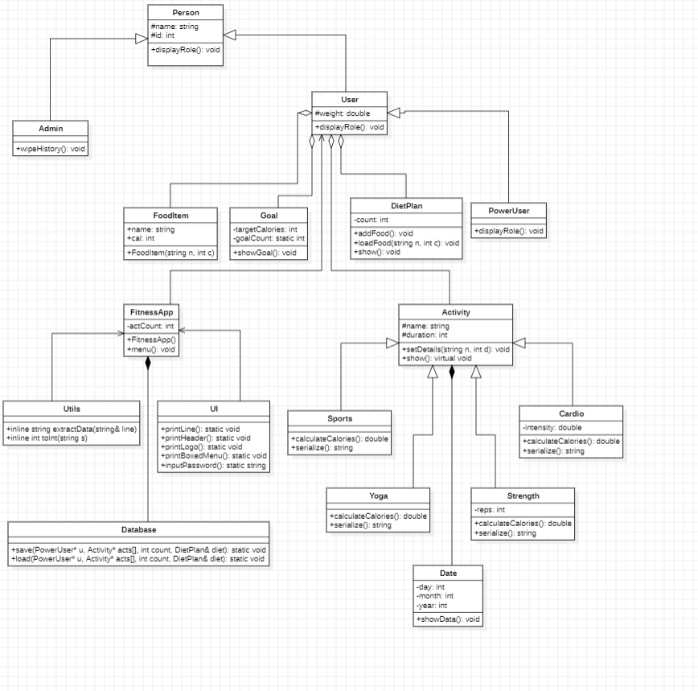
Core Functionalities:
One of the most important functionalities of the system is activity management and tracking. The application allows users to add different types of physical activities such as cardio exercises, strength training, yoga sessions, and sports activities. Each activity type has its own internal logic for calculating calories burned, which makes the results more realistic and meaningful. All activities are stored dynamically, allowing the system to manage multiple records efficiently.
The system also provides a detailed activity history view, where users can see a complete list of previously added activities along with their duration and calculated calorie burn. This feature helps users understand their workout patterns and overall physical effort over time.
Another core functionality is diet plan management. Users can add food items with their respective calorie values, which are stored using dynamically allocated objects. The diet plan can be viewed at any time, providing a clear summary of calorie intake. This functionality complements activity tracking by allowing users to balance calorie consumption with calorie expenditure.
The project includes a goal tracking mechanism that compares the total calories burned from activities against a predefined daily calorie goal. Operator overloading is used to perform goal comparison in a clean and readable way. This feature gives immediate feedback on whether the fitness target has been achieved.
A role-based access system enhances control and flexibility within the application. The PowerUser role combines standard user features with administrative capabilities, such as resetting stored fitness data. This demonstrates how different levels of access can be implemented within the same system.
The application also ensures data persistence through file handling. All user details, activities, and diet records are saved to external files and automatically loaded when the program starts again. This ensures continuity and prevents data loss.
Finally, the system includes user interface utilities that improve interaction and readability. Structured menus, formatted output, headers, and secure password input contribute to a clean and user-friendly console experience.

Is There Any Novelty?:
While the project follows standard OOP principles, its novelty lies in the integrated use of multiple advanced OOP concepts within a single console application. The combination of virtual inheritance, dynamic polymorphism, operator overloading, deep copying, and file persistence in one cohesive system makes the logic unique and academically strong.
Additionally, the PowerUser role, which resolves the Diamond Problem practically, and the structured serialization/deserialization of activities and diet data add uniqueness to the project’s design.

Why This Project?:
This project addresses the common problem of unstructured fitness tracking, where individuals often rely on memory or scattered notes to monitor their workouts and diet. Such methods are unreliable and make it difficult to analyze progress over time. By providing a structured digital system, this project offers a clear and organized way to record and review fitness-related data.
The project was selected because it represents a realistic and relatable problem domain that can be effectively modeled using Object-Oriented Programming. Fitness tracking naturally involves multiple interacting entities such as users, activities, goals, and diet plans, making it an ideal case for applying OOP principles.
In addition, the project allows the application of both basic and advanced C++ concepts within a single system. It demonstrates how abstraction, inheritance, polymorphism, and dynamic memory management can work together to form a cohesive solution. This makes the project meaningful not only as a functional application but also as a strong demonstration of programming concepts.

Screenshots of project with Flow:
1.Passward Entry:
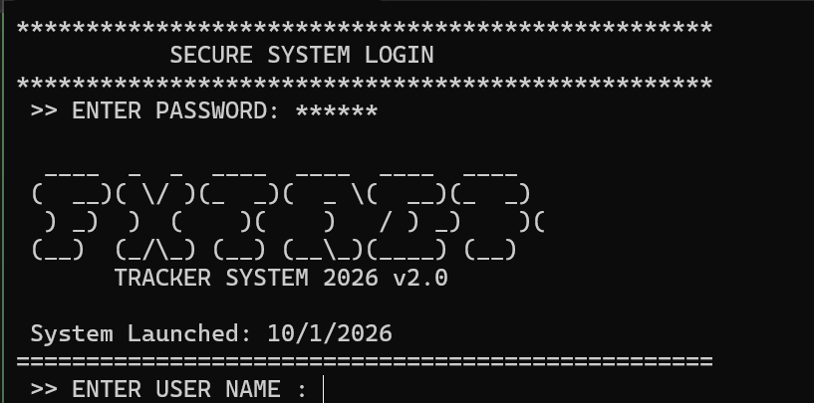

2.GIVING MY DETAILS FOR PROFILE CREATION:
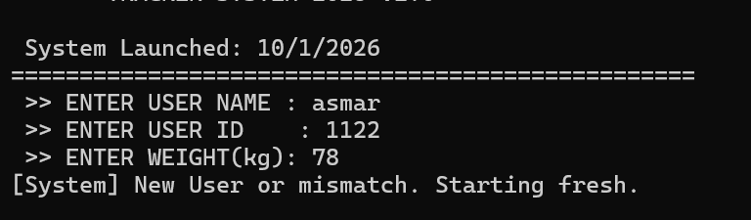

3.ADDING ACTIVITY:
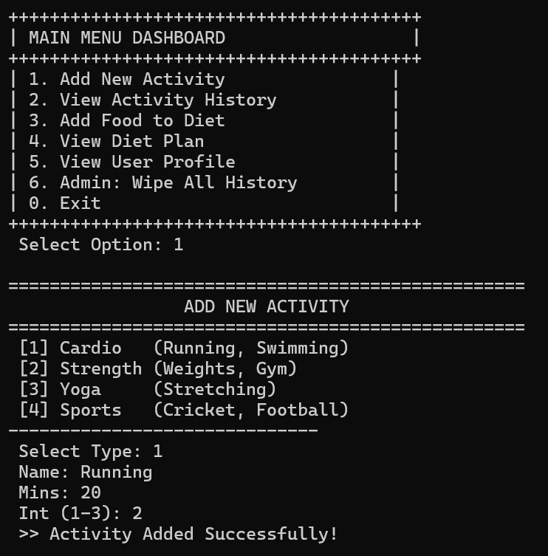

4.VIEWING DAILY ACTIVITY:
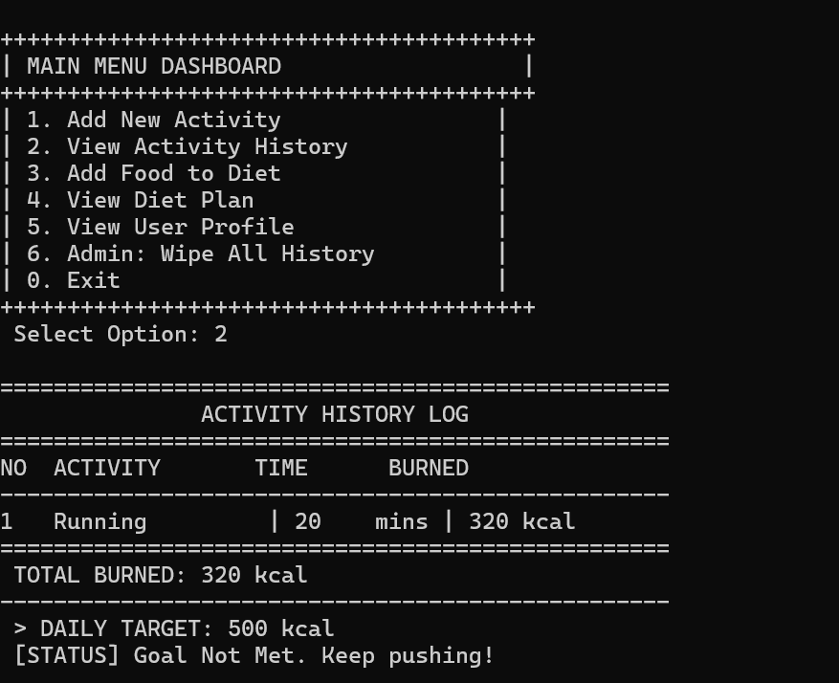

5. ADDING NEW FOOD ITEM:
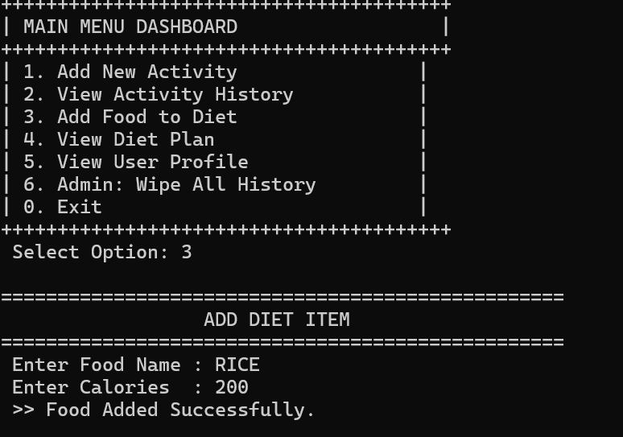
6. VIEWING MY FOOD INTAKE:
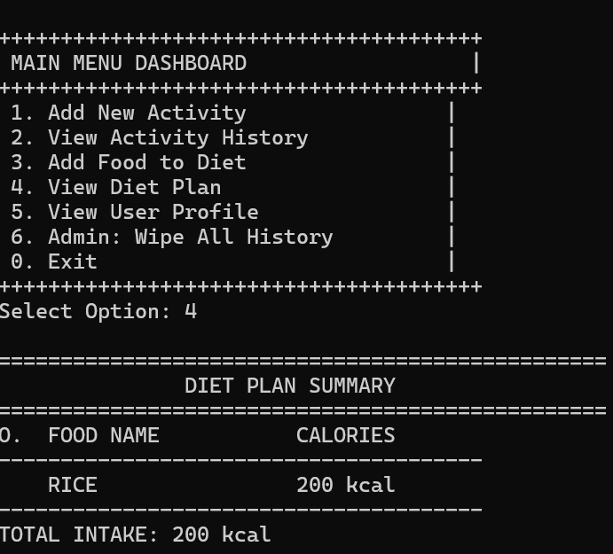

7.VIEWING YOUR PROFILE:
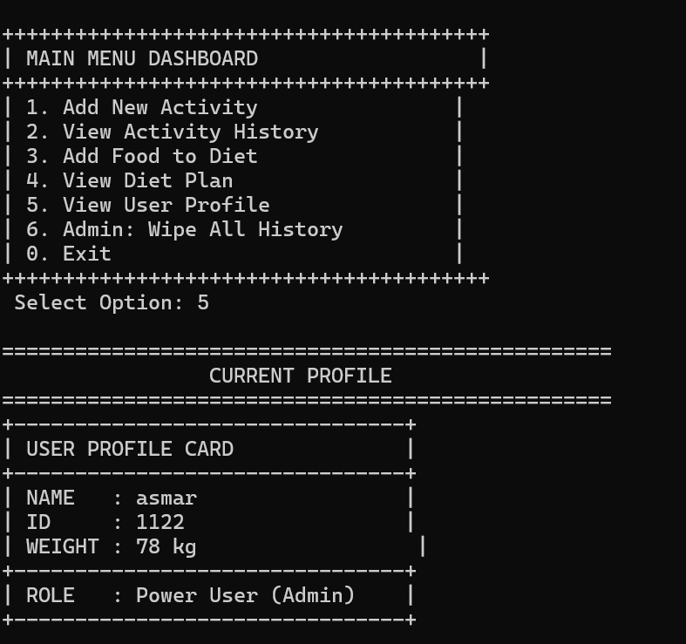
8. CLEARING ALL PROFILES:
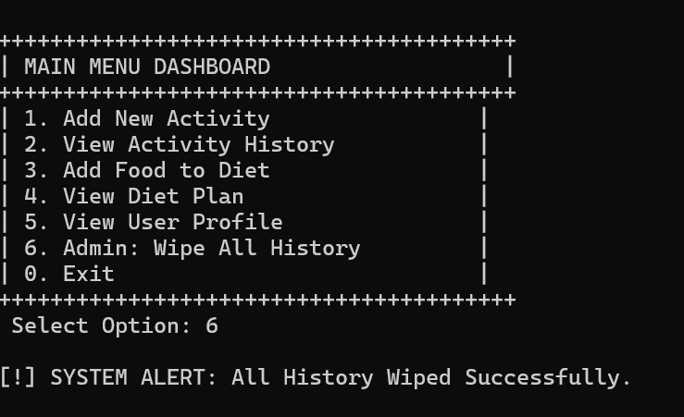
9. EXITING THE PROGRAM:
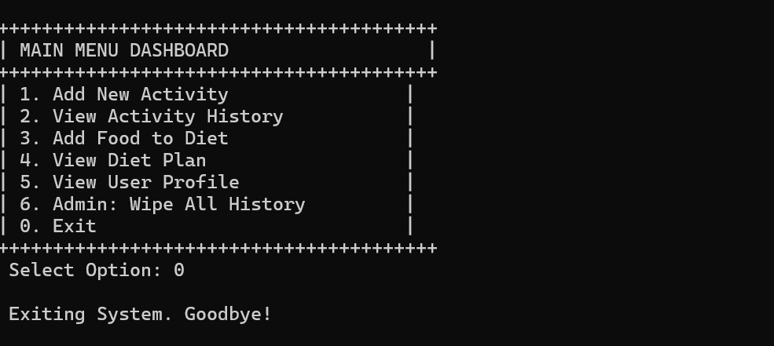

Learning Outcomes:
Through this project, a strong understanding of Object-Oriented Programming principles was developed, especially in designing systems using abstraction and inheritance. The importance of structuring code into reusable and manageable components became clear.
The project also improved skills in dynamic memory management, file handling, and runtime polymorphism, which are critical for building real-world C++ applications. Debugging memory-related issues and ensuring proper cleanup enhanced problem-solving abilities.
Overall, this project strengthened confidence in explaining code logic during oral explanation, understanding how different classes interact, and applying OOP concepts to solve practical problems in a clean and organized manner.

Recording of Console:

